**MHMessenger Application**

**CHG0023251: MEL - Fuel Order Form - Aircraft Status**

* On hitting this url on the browser <http://localhost:8085/MobileApp/MobileApp/>

It should display a login page and post login user should be able to login in the application.

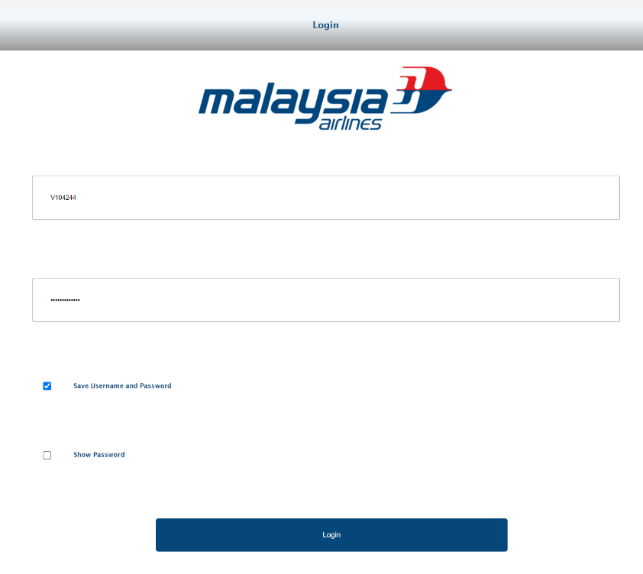

* Landing page menu

Landing page must contain Aircraft status feature.

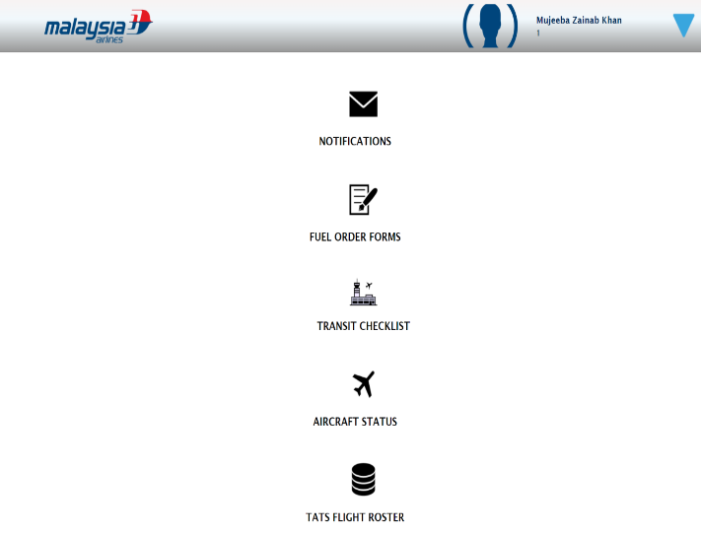

Aircraft Status (for Admin)

1. If User (2101642) is an admin then he/she should be able to get details of all aircrafts.

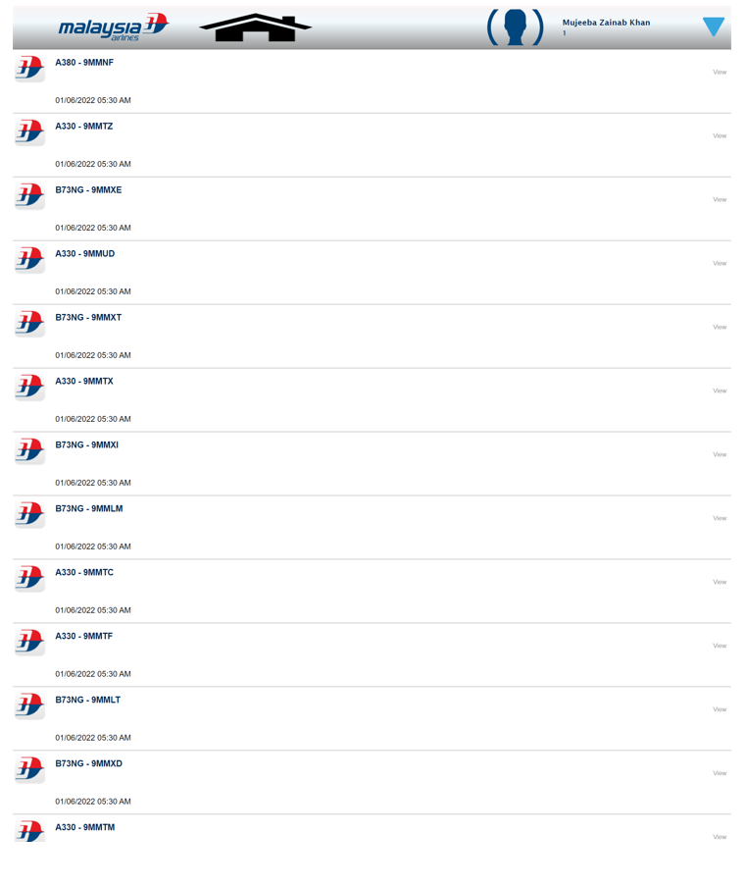

1. Onclick of each REG no. user will get more details like issue-date, due-date, MEL_REF etc.

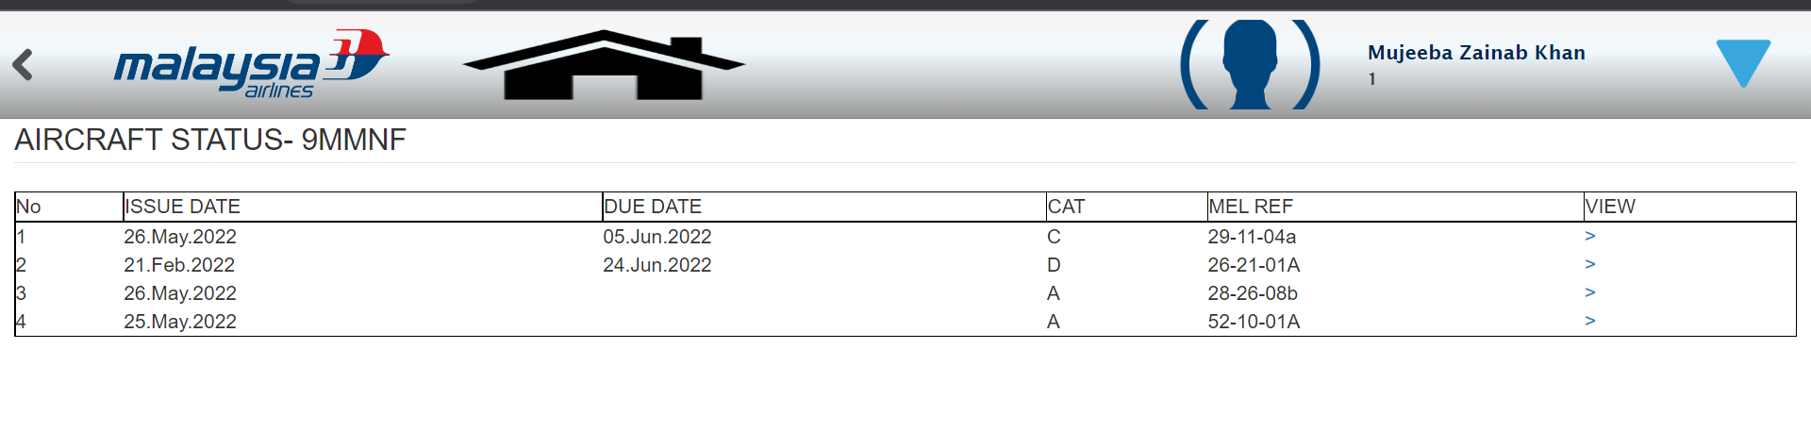

1. By clicking on View - user will get further MEL details.

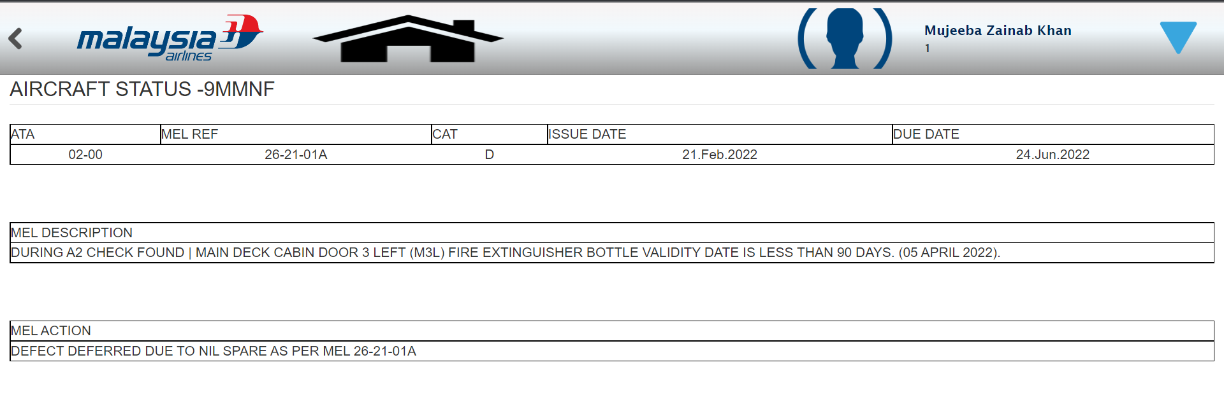

Aircraft Status (for Others)

1. If User (2354071) is not an admin then he/she should be able to get details of aircrafts as per REG no.

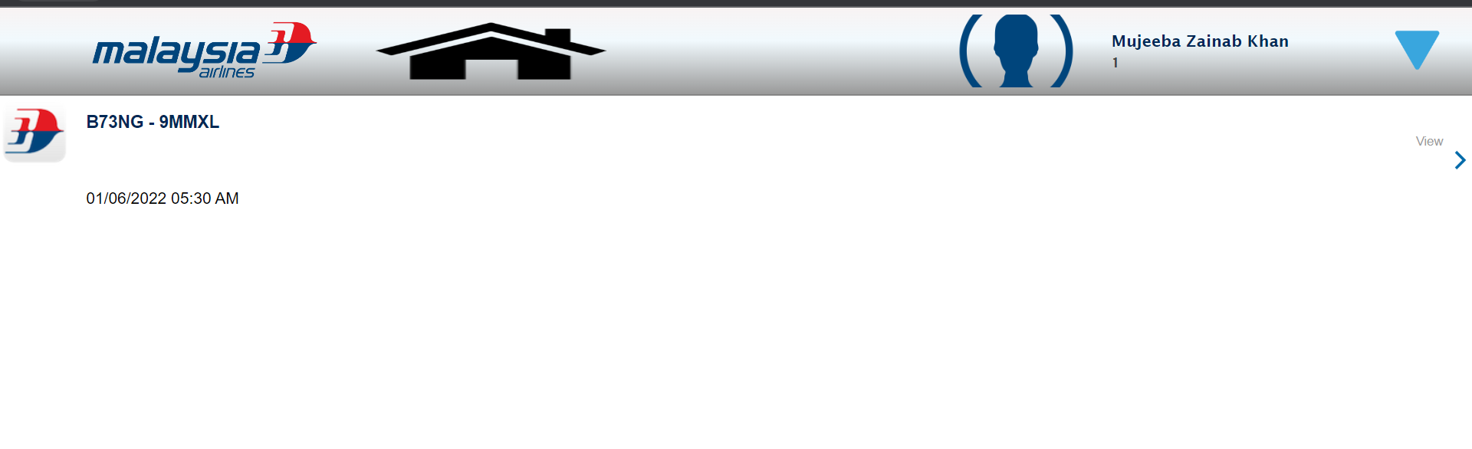

1. Onclick of each REG no. user will get more details like issue date, due date, MEL_REF etc.

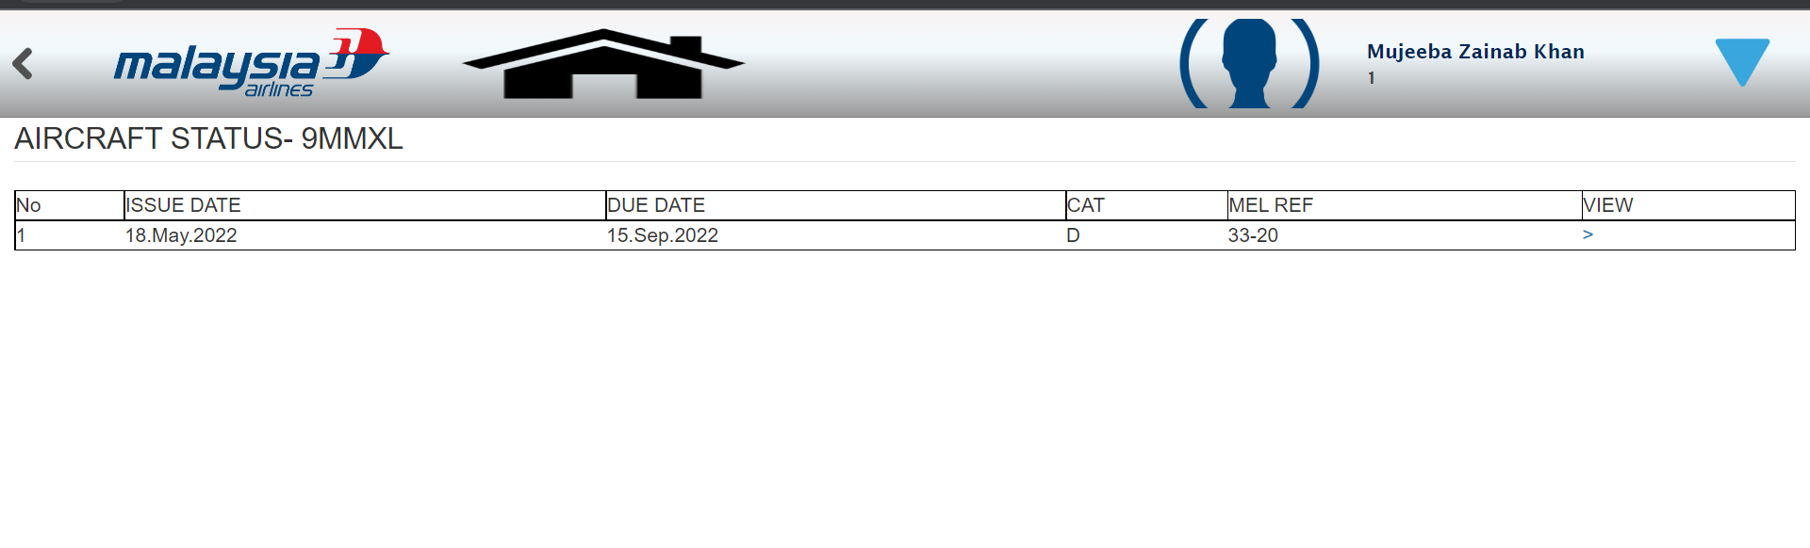

1. By clicking on View - user will get further MEL details.

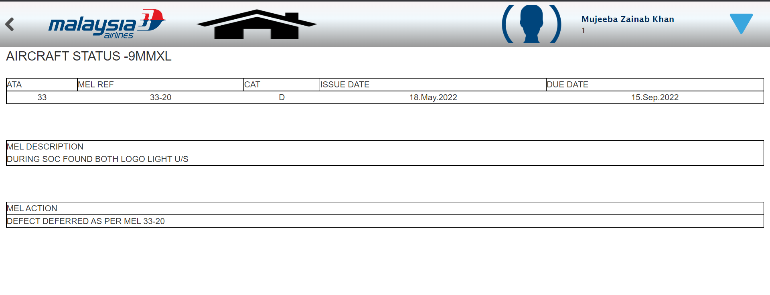

If the details of particular aircraft are not present in the database, then user will get an alert saying ‘No Data Available to Display’.

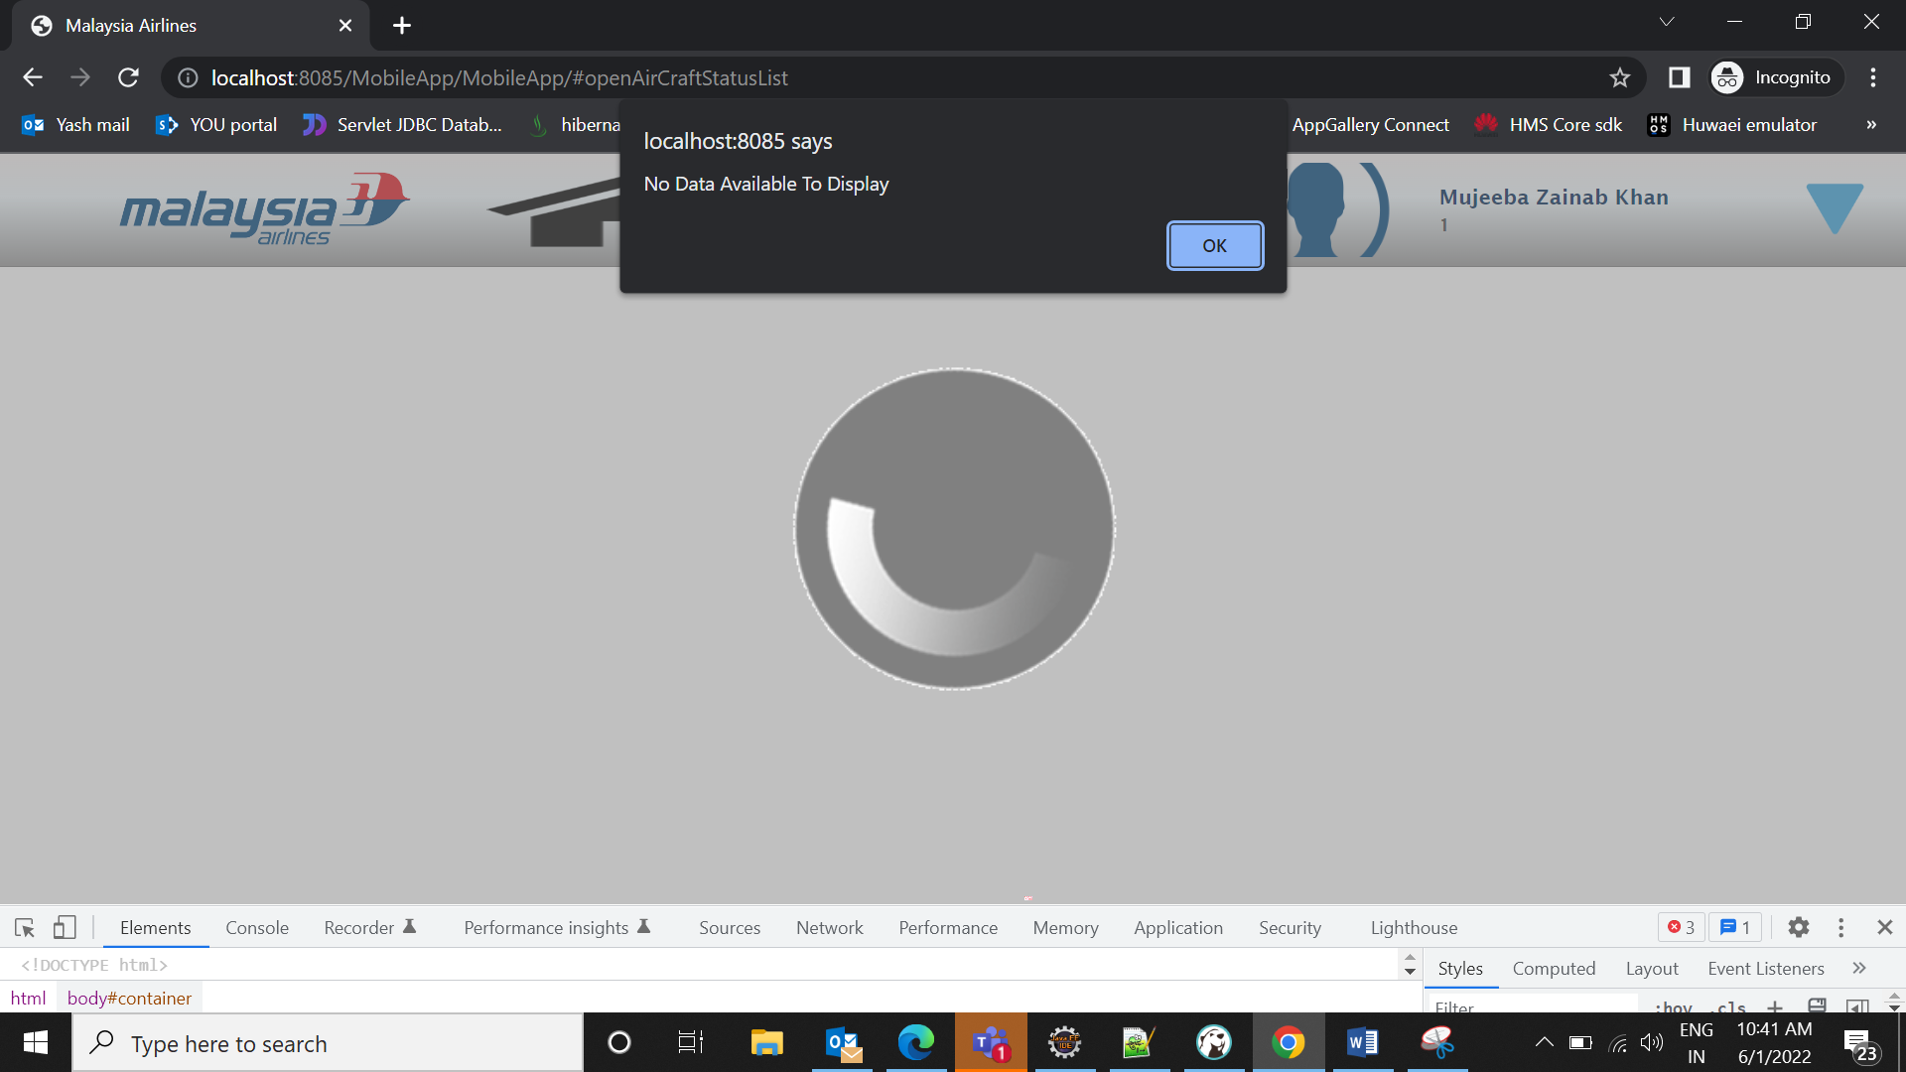

FOF - Fuel Order Form (for Admin)

1. If User (2101642) is an admin then he/she should be able to see FOF for all aircrafts.

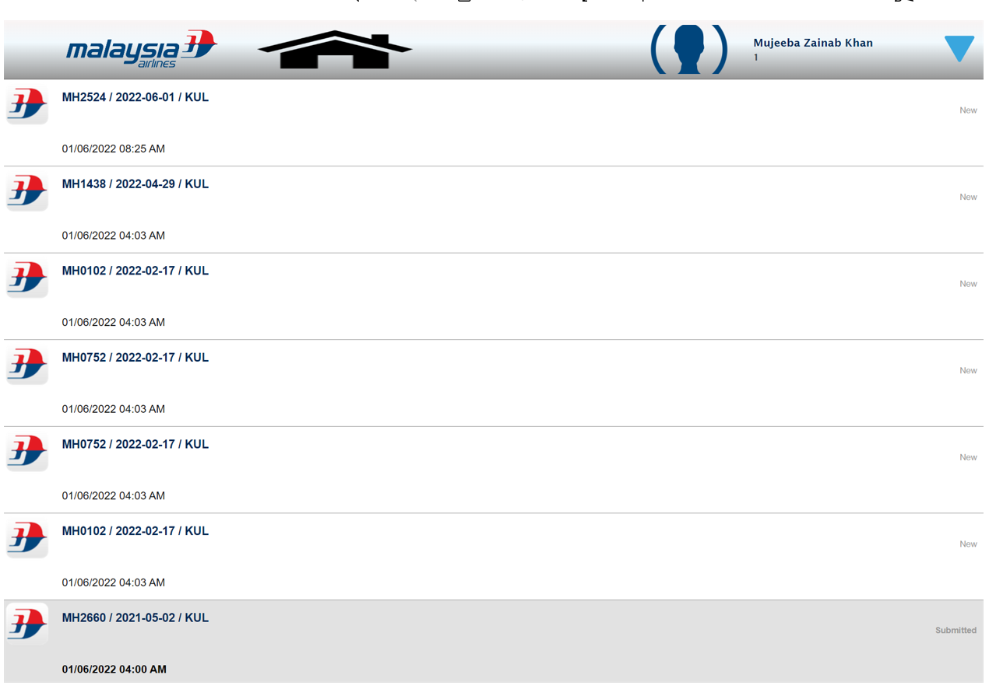

1. By clicking on New - user will be able to see the completely New Fuel Order Form

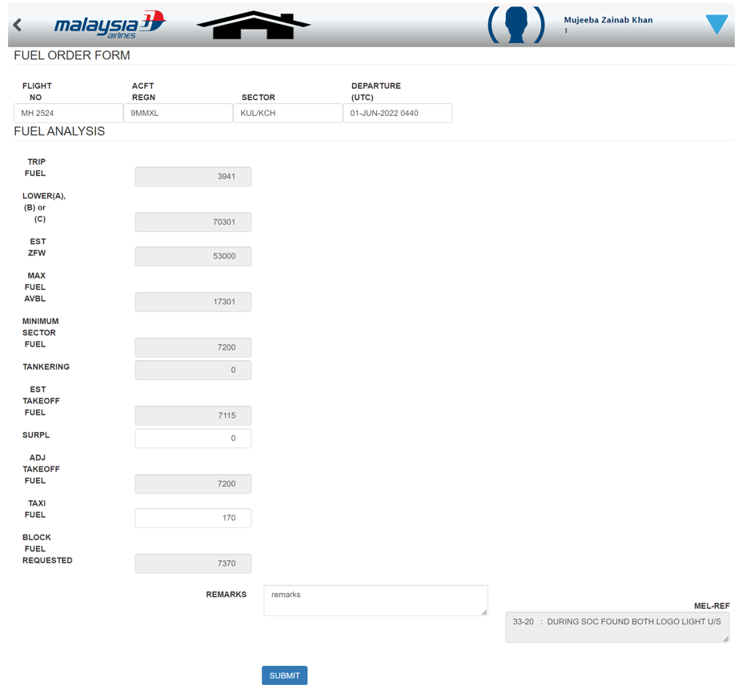

1. By clicking on Submitted - user will be able to see the Submitted Fuel Order Form

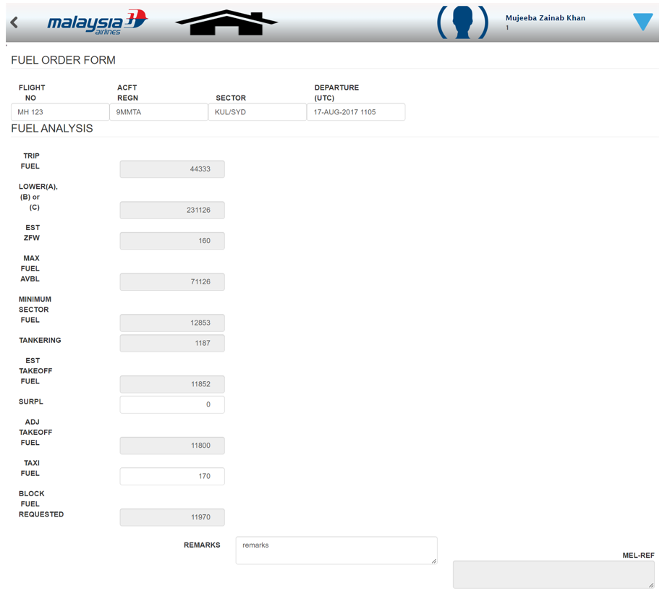

FOF - Fuel Order Form (for Others)

1. If User (2354071) is not an admin then he/she should be able to see FOF for aircraft assigned to him/her.

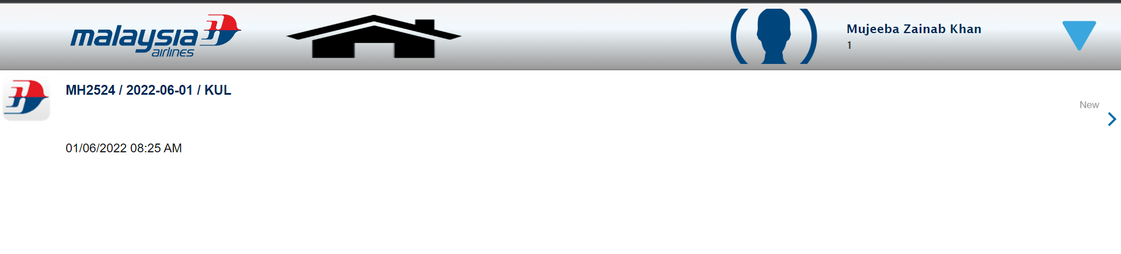

1. By clicking on New - user will be able to see the completely New Fuel Order Form

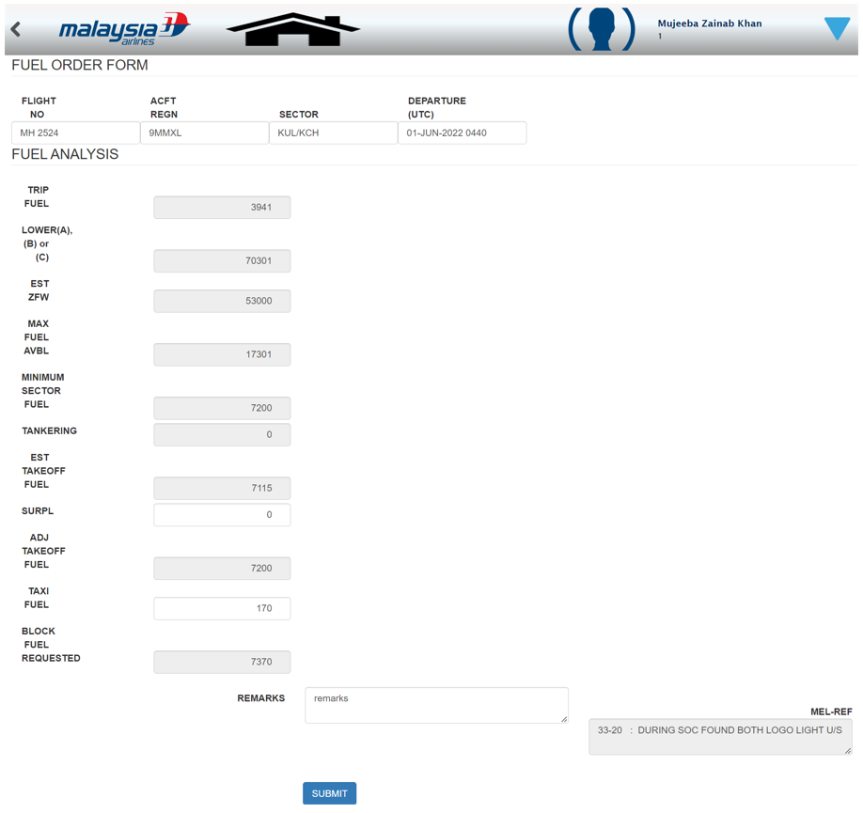

If the details of that FOF are not present in the database, then user will get an alert saying ‘No Forms Available to Display’.

